Git and GitHub Challenge
1 Resolve Merge Conflicts
The process of manually addressing competing changes in a shared codebase that a version control system (like Git) could not automatically reconcile during a merge operation.
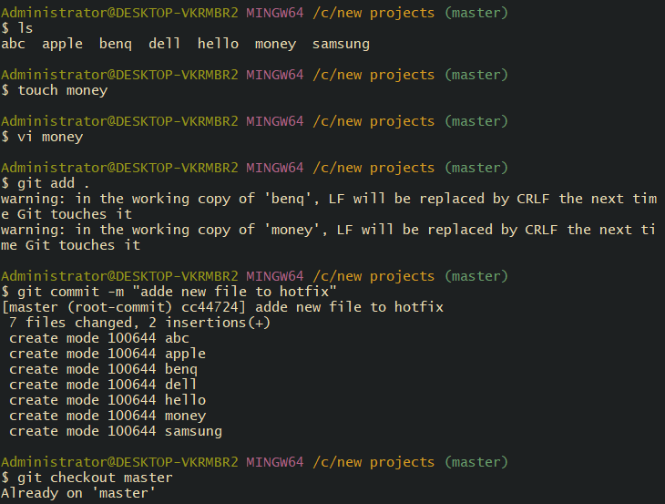

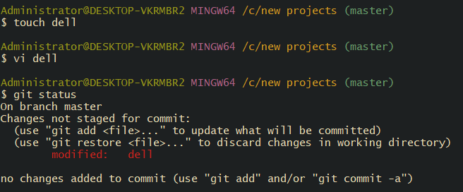

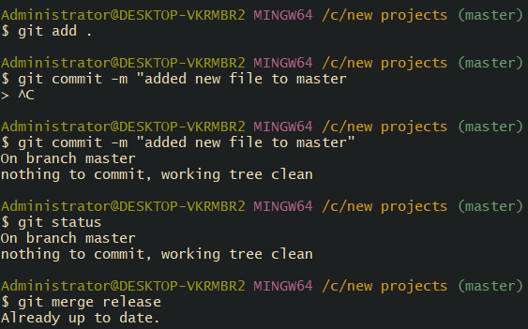
Updated the content in master branch in the file “money”
Changed the content from Hello superman to hi boys.
Once modified pushed to commit and merged the branches from master to hotfix.
Success merging is successful.

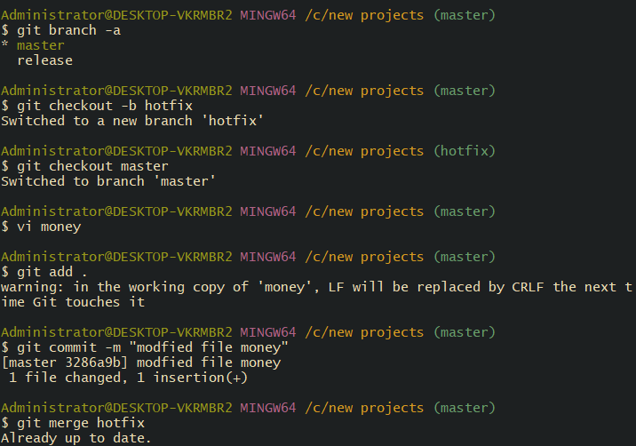
2. Recover Deleted Branch
Steps- Created a branch “admin” and verified the branch present by command- git branch –list.
Switched the branch to admin from master.
Created a file maker and commit performed.
Copied the commit id and switched to master branch.
Deleted the admin branch by command- git branch -D admin.
By using command- git reflog; we noticed all the commit are present.
Copied the commit ID from admin branch- file created and used command- git checkout -b admin commit ID.
Now the deleted branch is recovered.

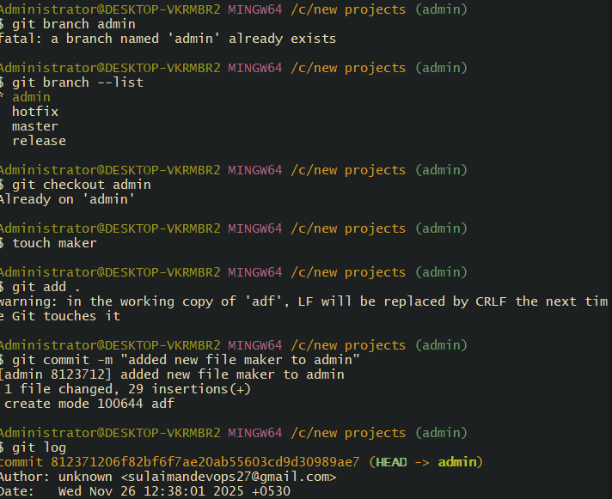

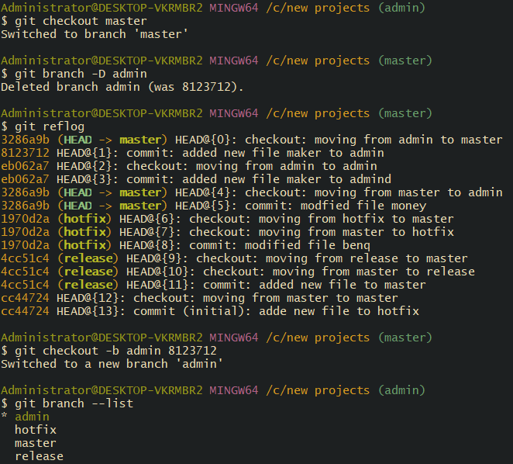

3. Undo Wrong Push
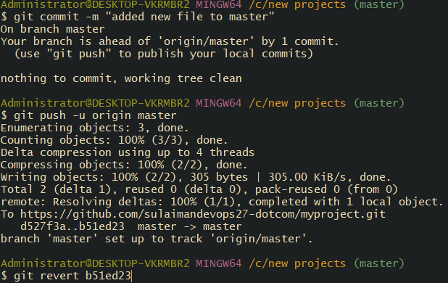
4. Amend a Commit
Make a commit, then add a missing file to it using git commit --amend.
Once the file is commit complete. Then we changed the name (from “revert in main” to “missing file” of commit using git commit –amend.
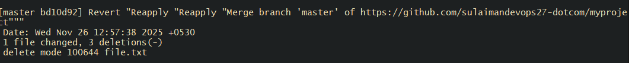
5. Cherry-pick a Commit
git cherry-pick = copy one specific commit from somewhere and apply it to your current branch.
Take a specific commit from one branch and apply it to another branch.
Created a file in release branch and commit performed.
Once Commit ID generated by command- git log
Copied the command and switched to master branch.
Used command- git cherry-pick (commit id pasted)
Success- the commit id is branched to master branch.
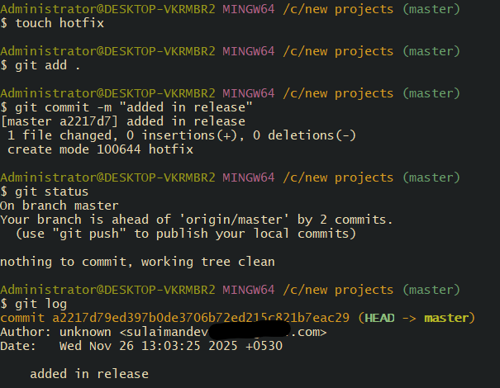
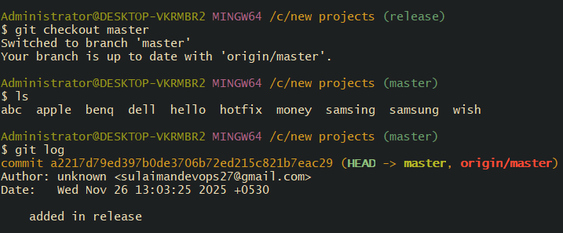

6 Interactive Rebase
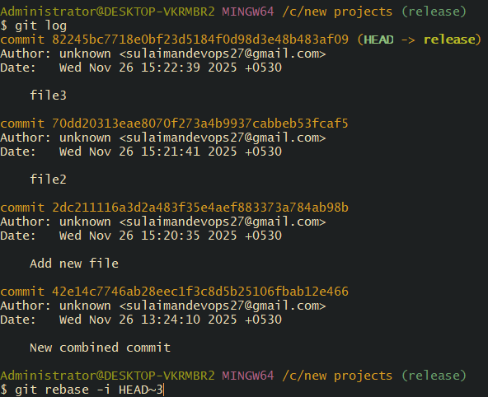
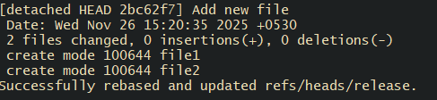

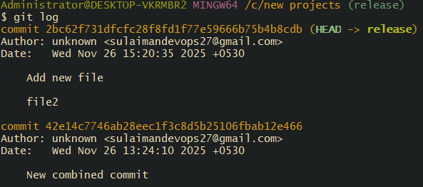

7 Tagging & Release

Create a version tag (v1.0), push it to GitHub, then delete and restore it.
Created a git tag by using command- git tag -a v1.0 commit -m “message
a is annotated tag and m is message for the tag.
Using command- git tag, we can verify if the tag is added.
Using command- git log, verified if the tag is added to the commit.

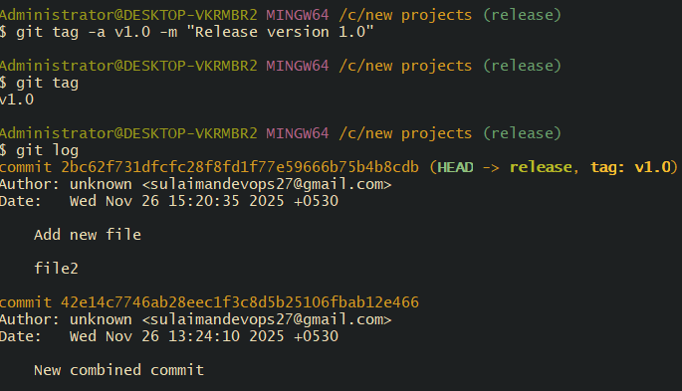
Once tag is added to the commit, we need to push to the repo- command- git push origin (version)
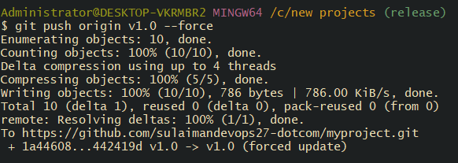

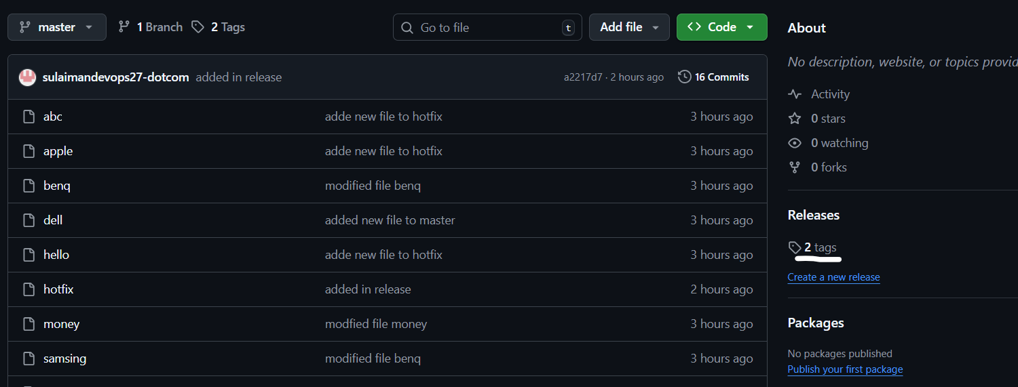

Now we are deleting the tag by using command- git tag -d (version)
Again, we are restoring by the same command which we used for creation- git tag – a v1.0 commit -m “message”

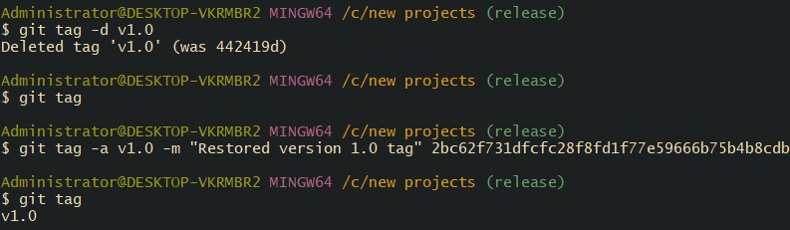

8. Reset vs Revert Challenge
Demonstrate the difference between git reset --hard and git revert in a repo
Using command- git –oneline, I verified the commit logs present in my master branch.
Command- git reset --hard (42e14c7) to remove the head commit.
Head commit has been deleted.

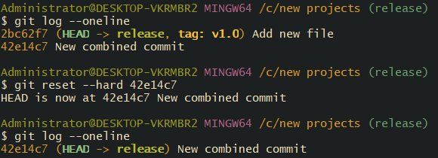
Git revert
Created a file addedcommit done
Verified the newly commit file by command- git log --online.

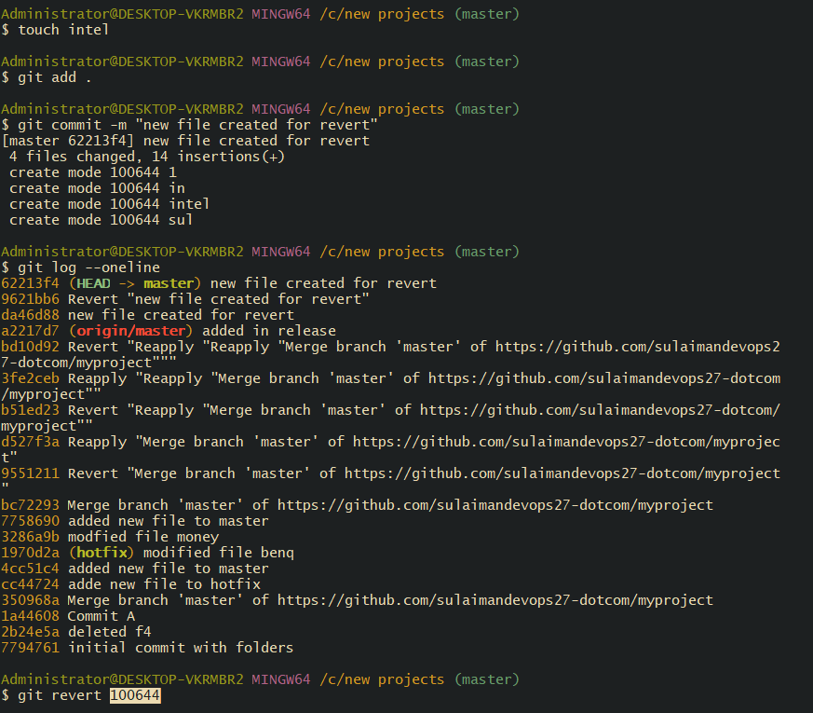

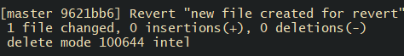

9 . Detached HEAD Challenge
Checkout a specific commit (detached HEAD state) and create a new branch from it.
Using command git log --oneline, we verified the commits.
Now, we need to use command- git checkout d45bb33 (Head commit).
Now the git branch will be checked out to the commit branch.By verifying in git branch, now we can see the commit is
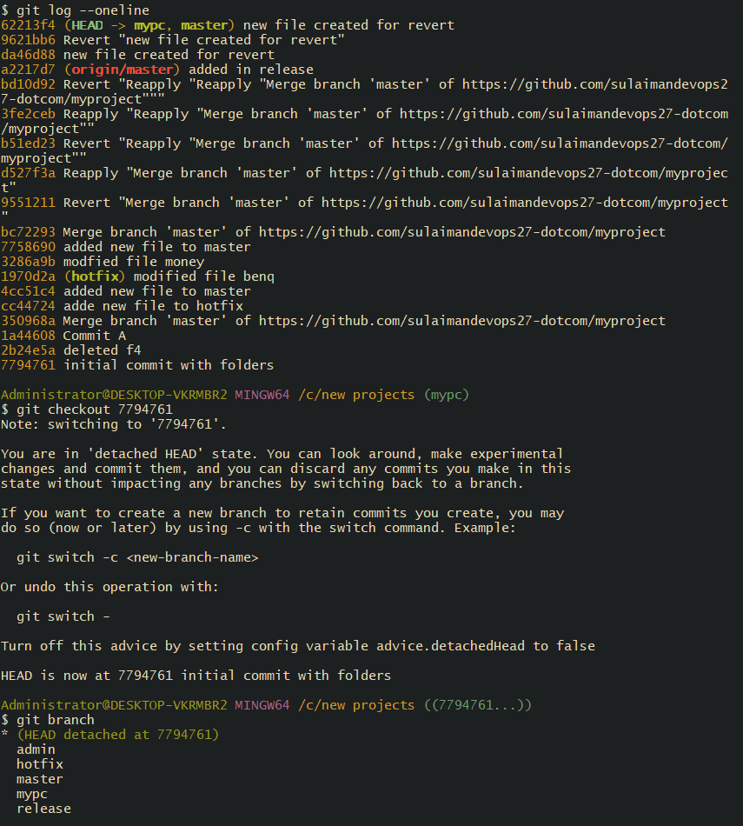

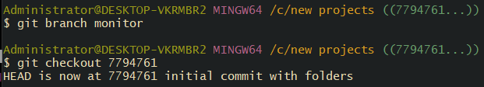

10. Squash Merge vs Rebase Merge
Show the difference between squash merge and rebase merge with evidence.
Created a new branch called -develop.
Created two files and two different commits.
Using command- git log -- online -- graph -- decorate -n 5, we can select only 5 commits.
Then we switched back to Master branch
Using command- git merge -- squash develop, we can commit all commits to one commit. Now only one commit appears to be on main.
Now the final step is to commit- git commit -m “Squashed develop”
Success- now the Squash merge is complete
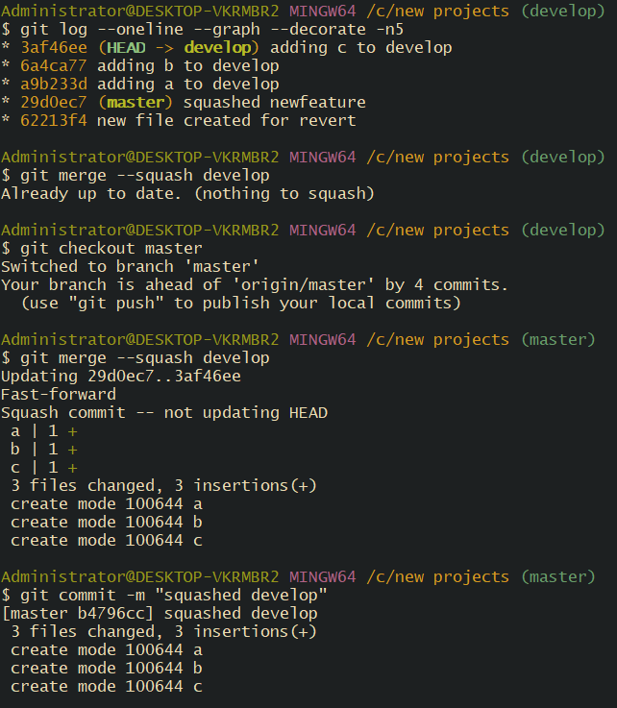
Rebase Merge:
For git rebase merging, the following process is to be followed.
Command- git reset – hard HEAD~1- to make second top commit to Head.
Git log confirms the second commit is at Head now.
Command- git rebase master will feature on to main branch.
Now, its time to checkout to master branch and merge both branches.
Success, now the commits are separated and they are into their own.
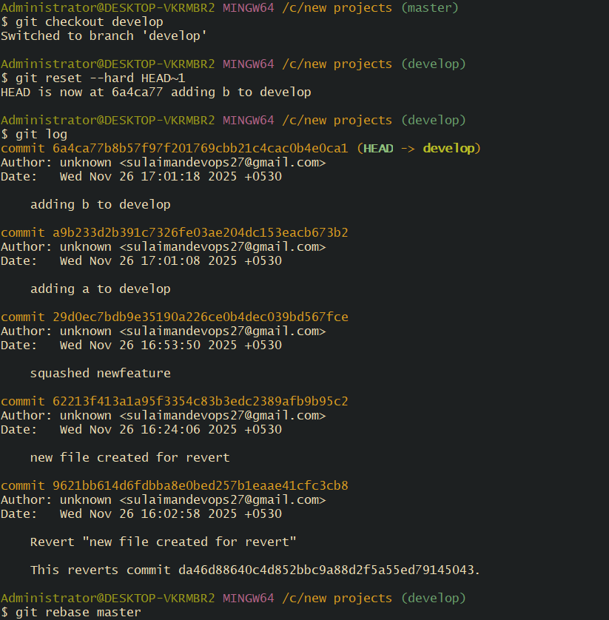

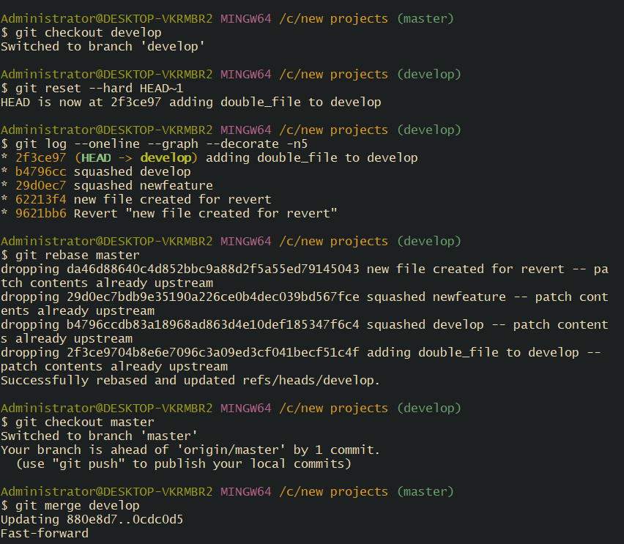

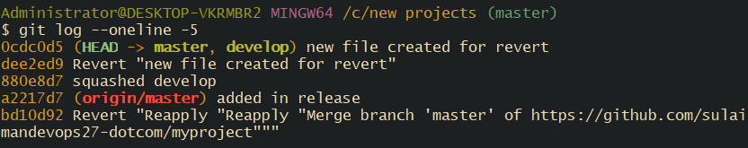
Squash merge:
Combines all commits into one commit
History becomes clean
Looks like a single change

Rebase merge:
Replays commits one-by-one
Produces all original commits on main
History is linear and detailed
11. Fork & Pull Request Workflow
Fork a repo, make a change, and submit a pull request to the original repo.
Forked with Lalitha in repo with a link.
Created a name and repo is active with Lalitha
In Git, cloned repo to local
Made a change using Vi and file.
Pushed the updated changes to GitHub
Success.
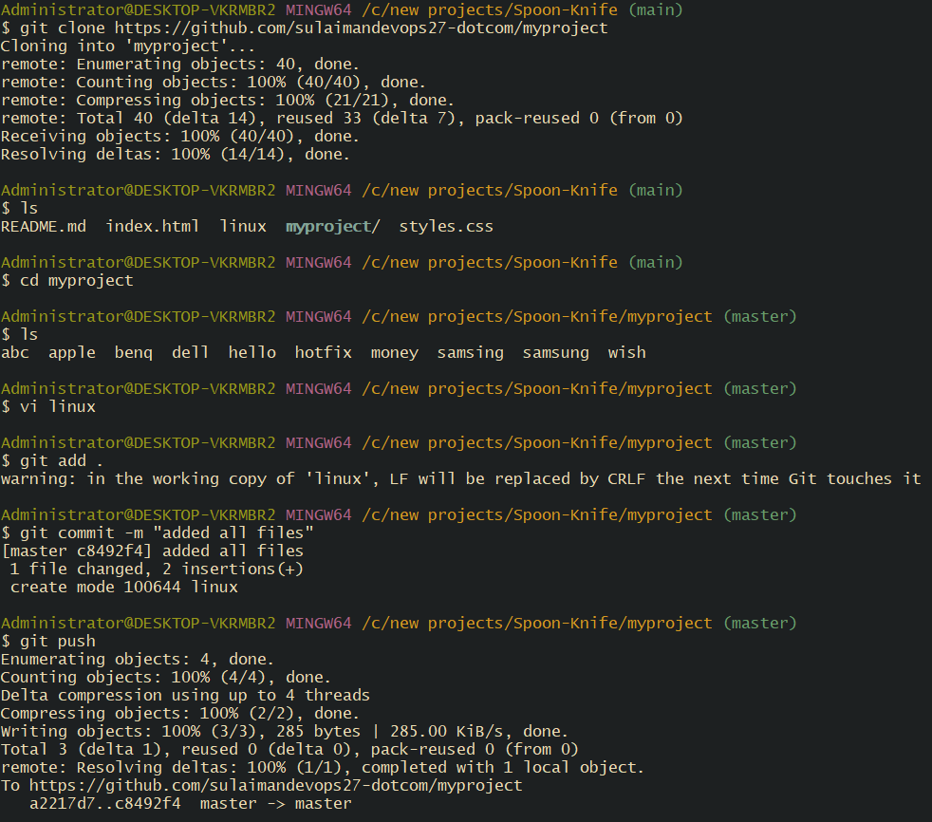

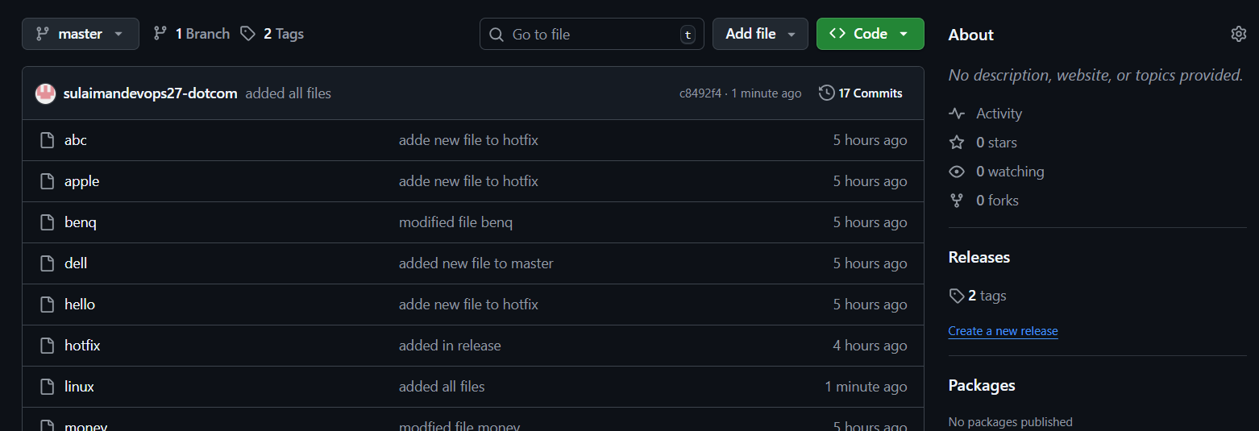

12. Recover Lost Commit
Commit something, reset hard, and then recover it using git reflog
Added a new file git add . git commit done
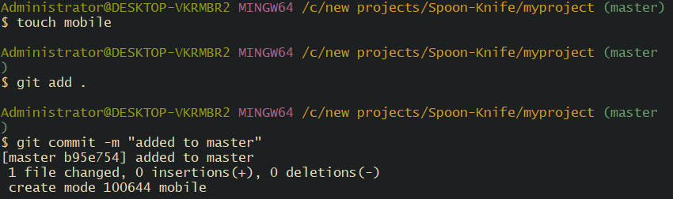

Command- git log –oneline to verify the commits in oneline.
Command- git reset –hard HEAD~1 – this will remove the head commit.
Now to recover, use command- git reflog
Command- git reflog will show us the information record.
To recover the deleted commit, we copied the commit ID.
Now the final step is to – git checkout (commit ID)
To verify- command- git log –oneline.
We can see the commit is recovered to Head.

